**T01: Introduction To Networking**

**Q1:** Fill in the table to indicate the layers that handle each of the following functions:

|  |  |  |
| --- | --- | --- |
| **Function** | **OSI Model Layer ?** | **TCP/IP Model Layer ?** |
| Dividing the transmitted bit stream into frames | Data link layer (layer 2) | Network access (layer 2) |
| Determining which route to use through the subnet (LAN) | Network (layer 3) | Network access (layer 2) |
| Determining which route to use through the internet | Network (layer 3) | Internet (layer 3) |
| Determining which application to communicate with in a remote host | Session (layer 5) | Transport (layer 4) |

**Q2:** Consider the following case studies:

1. The French and Chinese Prime Ministers need to come to an agreement by telephone, but neither speaks the other language. Further, neither has on hand a translator that can translate to the language of the other. However, both prime ministers have English translators on their staffs. Draw a diagram (similar to a protocol stack) to depict the situation and describe the interaction at each level.

The French prime minister will communicate in French to the translator. The translator will then communicate that message to the Chinese prime minister in Chinese. The Chinese prime minister will then communicate to the translator in Chinese who will then relay that message to the French prime minister in French.

1. Now suppose that the Chinese Prime Minister’s translator can translate only into Japanese and the French Prime Minister has a German translator available. A translator between German and Japanese is available in Germany. Draw a new diagram that reflects this arrangement and describe the hypothetical phone conversation.

CNCO2000 – Tutorial 01



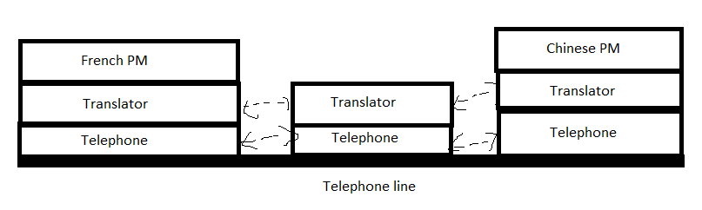

**Q3:** A man gets onto a Qantas flight to Sydney with 100 CDs full of data, each CD can store 650MBytes of data each. The plane travels to Sydney in 4.5 hours. Calculate the bandwidth (in bits per second) this communication medium can offer.

Total Data = 100 CDs * 650 MB/CD = 65,000 MB

65,000 MB * 8 bits/byte = 520,000 Mb

4.5 hours * 60 minutes/hour * 60 seconds/minute = 16,200 seconds

Bandwidth = Total Data / Time = 520,000 Mb / 16,200 seconds = 32.1 Mb/s

**Q4:** Given the following parameters for a switching network:

N = number of hops between two given end systems

L = message length in bits

B = Data rate in bits per sec (bps) on all links

P = fixed packet size

H = overhead (header) in bits pet packet

S = call setup time (circuit switching or virtual circuit) in seconds D = propagation delay per hop in seconds

Compute the end-to-end delay for

1. **Circuit Switching**,
2. **Packet Switching**
   1. | P a g e
3. **Virtual Circuit Packet Switching**.

*Assume that there are no acknowledgements and ignore processing delay at the nodes.*

**Q5:** Compare and contrast Circuit Switching, Packet Switching and Virtual Circuit Packet Switching networks while providing example for each of the networks?

Circuit Switching creates a dedicated physical path between two devices for communication. Packet Switching transmits data in small packets that take different paths to reach the destination. Virtual Circuit Packet Switching combines both by creating a virtual circuit between the source and destination devices before transmission, ensuring packets arrive in order. Traditional telephone networks are circuit-switched, the internet is packet-switched, and the ATM network is virtual circuit packet-switched.

CNCO2000 – Tutorial 01



* 1. | P a g e